Name:  Teacher: | ____________________________________  __________________________ |  | Date: _________
 | Year 7 Mathematics  Topic – Fractions, Decimals, Percentages and Ratio |  | / 25  %
Total Time: | 40 minutes
Weighting: | 4 %
Equipment: | Pen, pencil, ruler
Notes: | Show working and answers on this sheet. Show working in sufficient detail to support your answers. Incorrect answers without supporting reasoning will be allocated zero marks.

- $5×2.4$

- $0.02×0.3$

- $35×\$10.40$

(10 marks)
- $215÷0.4$

- Find 10% of 350

- Find 5% of 110

- Complete the table by converting between decimals, fractions and percentages. (4 marks)

Decimal | Percentage | Fraction
0.1
 | 0.05%
 |  | $$\frac{1}{4}$$
1.36

- Complete the table below by referring to the triangles, squares and circles (4 marks)
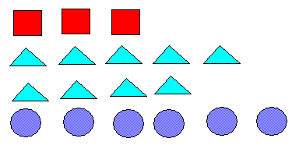
- Write a ratio for circles to triangles | - Write a ratio for triangles to squares
- Write a ratio for triangles to circles to squares | - Write a ratio of circles to total shapes

- Simplify the ratios (3 marks)

$$12 :24$$ | $$14:35$$ | $$20L :565mL$$

- Complete the following equivalent ratios (2 marks)
$$25 :10= ______ :30$$ | $$3 :2= 9 : ________$$

- Share 20 lollies in a ratio of 3 : 2 (2 marks)

